**GREEN SYNTHESIS OF COPPER OXIDE NANOPARTICLES (CUO NP) USING *GONGRONEMA LATIFOLIUM* (UTAZI LEAVE) EXTRACT FOR EFFECTIVE PHOTOCATALYTIC DEGRADATION OF DYE.**

**BY**

**Ezeata Raphael Anayochukwu**

**2019/244928**

**A PROJECT SUBMITTED IN PARTIAL FULFILMENT OF THE REQUIREMENTS FOR THE AWARD OF B.SC DEGREE IN PURE AND INDUSTRIAL CHEMISTRY**

**DEPARTMENT OF PURE AND INDUSTRIAL CHEMISTRY**

**FACULTY OF PHYSICAL SCIENCE**

**UNIVERSITY OF NIGERIA, NSUKKA**

**PROJECT SUPERVISOR:**

# TITLE PAGE

**GREEN SYNTHESIS OF COPPER OXIDE NANOPARTICLES (CUO NP) USING *GONGRONEMA LATIFOLIUM* (UTAZI LEAVE) EXTRACT FOR EFFECTIVE PHOTOCATALYTIC DEGRADATION OF DYE.**

# CERTIFICATION

This is to certify that this research work titled: Synthesis, characterization and application of Zn-doped Fe2O3 nanoparticle for the removal of methylene blue dye from aqueous solution was originally done by Nwodo Emmanuel Chimaobi with registration number 2018/249227, has been approved by the undersigned as having met the standard of the department of Pure and Industrial Chemistry, University of Nigeria, Nsukka and has not been submitted either for diploma, any other if this or in any other university.

……………………………….. ………………………………..

DATE

(PROJECT SUPERVISOR)

……………………………….. ………………………………..

PROF. B. E. EZEMA DATE

(HEAD OF DEPARTMENT)

……………………………….. ………………………………..

EXTERNAL EXAMINER DATE

DEDICATION

This work is dedicated to God Almighty, my parent, my siblings

Acknowlegement

# Abstract

TABLE OF CONTENTS

**TITLE PAGE 2**

**CERTIFICATION 3**

**DEDICATION 4**

**ACKNOWLEGEMENT 5**

**ABSTRACT 6**

**TABLE OF CONTENTS 7**

**LIST OF TABLES 8**

**LIST OF FIGURES 9**

**LIST OF ABBREVIATION 10**

**CHAPTER ONE 11**

**INTRODUCTION 11**

**1.1 BACKGROUND STUDY 11**

**1.2 AIM AND OBJECTIVES 14**

**1.3 JUSTIFICATION AND SIGNIFICANCE 15**

**CHAPTER TWO 18**

**LITERATURE REVIEW 18**

**NUTRITIONAL USES OF *GONGRONEMA LATIFOLIUM* 18**

**ETHNOMEDICAL USES OF *GONGRONEMA LATIFOLIUM* 19**

**CHAPTER THREE 21**

**3.1 MATERIAL AND REAGENT USED 21**

**3.2 APPARATUS AND EQUIPMENT 21**

**3.4 PREPARATION OF THE LEAF EXTRACT 22**

**3.5 GREEN SYNTHESIS OF COPPER OXIDE NANOPARTICLES 23**

**3.5 CHARACTERIZATION AND ANALYSIS 25**

List of Tables

List of Figures

List of abbreviation

# CHAPTER ONE

INTRODUCTION

## BACKGROUND STUDY

Green nanotechnology has gained attraction in the synthesis of metallic nanoparticles due to their cost-effectiveness, simple preparation steps, and environmentally-friendly(Nzilu et al., 2023).

In recent years, the field of nanotechnology has seen significant advancements in the synthesis and application of nanomaterials for environmental remediation, with a particular focus on copper oxide nanoparticles (CuO NPs) (Akintelu et al., 2020; Majumdar & Ghosh, 2021; Panhwar et al., 2021). These nanoparticles have unique properties that make them promising candidates for various applications, including in the field of supercapacitors (Majumdar, 2020). The use of green synthesis methods, such as those involving plant extracts, has been highlighted as a cost-effective and environmentally friendly approach to producing CuO NPs(Akintelu et al., 2020; Joshi et al., 2019; Panhwar et al., 2021). These methods have the potential to scale up to large-scale production and have been shown to enhance the toxicity of CuO NPs against microbes, making them effective for environmental remediation (Akintelu et al., 2020; Panhwar et al., 2021).

### 1.1.1 Copper Oxide Nanoparticles (CuO NPs)

Copper oxide nanoparticles (CuO NPs) have shown promise in environmental applications due to their high surface area, catalytic activity, and photodegradation capabilities (Chauhan et al., 2020). These properties make them effective in degrading organic pollutants, as demonstrated in the degradation of dyes (Chauhan et al., 2020). Furthermore, CuO NPs have been explored for their potential in supercapacitor applications, with their unique advantages of low cost, high chemical stability, and remarkable electrochemical performance (Majumdar & Ghosh, 2021). The use of 3D hierarchical nanoporous structures of copper has also been investigated for the degradation of organic pollutants, showing high efficiency and reusability (Yang et al., 2018). The synthesis methods and applications of nanostructured copper oxide semiconductors have been reviewed, highlighting their unique properties and potential in various fields (Zoolfakar et al., 2014).

### 1.1.2 Green Synthesis: A Sustainable Approach

The concept of green synthesis, which utilizes natural sources such as plant extracts as reducing and stabilizing agents, has gained prominence as a sustainable approach to nanoparticle production (Murphy, 2008). This method not only reduces the environmental impact by avoiding toxic chemicals, but also enhances biocompatibility, making the nanoparticles safer for various applications (Jadoun et al., 2021). The use of green renewable resources and energy-efficient synthetic routes further contributes to the eco-friendliness of this approach (Madani et al., 2022). The potential of green synthesis in the preparation of metallic nanoparticles using plant extracts, ascorbic acid, and sodium citrate as green reagents is also highlighted (Adil et al., 2015).

### 1.1.3 *Gongronema latifolium* Extract: A Natural Resource

*Gongronema latifolium,* also known as Utazi Leaves, is a plant with a rich phytochemical composition, including flavonoids, alkaloids, and phenolic compounds (Udoidong et al., 2014).



Figure 1: Structure of flavonoids

Source from (Dias et al., 2021)



Figure 2: Simple substituted phenol compounds

Source from (Mamari, 2021)

These compounds contribute to the plant's antioxidant, antibacterial, and anti-inflammatory properties (Adekanle & Omozokpia, 2015). The plant has a wide range of nutritional and ethnomedical uses in different tropical African communities, and its extracts have potential applications in herbal formulations, food preservation, alcoholic fermentation, drug discovery, and allelopathy (Morebise, 2015). Furthermore, the methanol extract of Gongronema latifolium has been found to possess significant anti-hyperglycemic and antioxidant activities (Chidi, 2017)

### **1.1.4 SYNERGY OF CUO NPS AND UTAZI EXTRACT**

The combination of CuO NPs and Utazi extract, as explored by Raizada (2020), has shown potential in addressing environmental challenges, particularly in the photocatalytic degradation of dyes in wastewater(Raizada et al., 2020). This approach is in line with the broader trend of using nanoscale metal oxide materials for water treatment, as discussed by Raizada et al. (2020). The enhanced photodegradation activity of CuO NPs, as demonstrated by Rasheed, further supports the potential of this combination. The use of CuO NPs in the purification of dye-polluted water, as highlighted by Rafique et al. (2020), also underscores the effectiveness of this approach. Saghir (2020) further emphasizes the importance of efficient adsorbents in wastewater treatment, which could potentially be complemented by the CuO NPs and Utazi extract combination(Saghir et al., 2020).

## **1.2 AIM AND OBJECTIVES**

Aim: The aim of this research paper is to explore the green synthesis of copper oxide nanoparticles (CuO NPs) using *Gongronema latifolium* (Utazi Leave) extract and investigate their effectiveness as a photocatalyst for the degradation of dyes in wastewater treatment.

Objectives:

1. To synthesize CuO nanoparticles using *Gongronema latifolium* extract via a green synthesis method.
2. To characterize the synthesized CuO nanoparticles using techniques such as TEM, SEM, XRD, and FTIR to confirm their size, morphology, crystallinity, and chemical composition.
3. To evaluate the photocatalytic activity of the synthesized CuO nanoparticles for the degradation of a selected dye under UV or visible light irradiation.
4. To compare the photocatalytic efficiency of CuO nanoparticles synthesized with *Gongronema latifolium* extract with that of conventional methods or other green synthesis approaches.
5. To investigate the potential mechanisms involved in the photocatalytic degradation process, such as the generation of reactive oxygen species (ROS) and the adsorption of dye molecules onto CuO nanoparticle surfaces.
6. To discuss the implications of the findings in terms of the application of green-synthesized CuO nanoparticles for environmentally friendly wastewater treatment strategies.

## **1.3 JUSTIFICATION AND SIGNIFICANCE**

The justification for this research lies in addressing critical environmental and technological challenges. Traditional methods of dye degradation in wastewater are often energy-intensive, chemically hazardous, and environmentally detrimental. Green synthesis of copper oxide nanoparticles (CuO NPs) using plant extracts offers a sustainable alternative with reduced environmental impact. *Gongronema latifolium* extract, known for its bioactive compounds, can serve as a green reducing and stabilizing agent for CuO NP synthesis (Nzilu et al., 2023). This approach aligns with the principles of green chemistry by minimizing waste generation and utilizing renewable resources.

Significance:

1. Environmental Sustainability: The use of green-synthesized CuO NPs represents a step towards sustainable wastewater treatment. It reduces the reliance on chemical methods that contribute to pollution and resource depletion (US EPA, 2015).
2. Cost-Effectiveness: Utilizing plant extracts for nanoparticle synthesis can be cost-effective compared to conventional methods involving expensive precursors and energy-intensive processes.
3. Efficient Photocatalysis: CuO NPs have shown promising photocatalytic activity in degrading organic pollutants. Investigating their efficacy using *Gongronema latifolium* extract adds to the knowledge base of eco-friendly photocatalytic materials(Sibhatu et al., 2022).
4. Biocompatibility: Green-synthesized CuO NPs are expected to be biocompatible and less toxic, making them suitable for applications in water treatment without adverse effects on aquatic life or human health(Ranjha et al., 2022).
5. Potential for Scalability: Green synthesis methods are scalable and adaptable for large-scale production, offering practical solutions for industrial wastewater treatment plants(Gao et al., 2022).
6. Contribution to Nanotechnology: The study contributes to advancing the field of vnanotechnology by exploring innovative approaches for nanoparticle synthesis and their application in environmental remediation.

In summary, this research is significant as it combines principles of green chemistry, nanotechnology, and environmental stewardship to develop a sustainable solution for dye degradation in wastewater, with broader implications for eco-friendly technologies in various industries

# CHAPTER TWO

## LITERATURE REVIEW

*Gongronema latifolium* Benth belongs to the family *Asclepiadaceae*. It is an edible nutritional/ medicinal plant mostly found in the rain forest zones in Nigeria and other tropical African countries (Chattopadhyah, 1999; Hutchinson & Dalziel, 1931). The plant produces white latex and yellow flowers (Hutchinson & Dalziel, 1931) and can be propagated by seed or stem cuttings (Edim et al., 2012). *G. latifolium* is known by the Ikales of Ondo State of Nigeria as Iteji (Morebise et al., 2006; Morebise & Fafunso, 1998). The Igbos call the plant Utazi, the Efik/ Ibibio call it Utasi while the Yorubas call it Arokeke (Edim et al., 2012). To the Akan-Asantes of Ghana, G. latifolium is known as Kurutu Nsurogya; the Serers of Senegal call it Gasub while to the Kissis of Sierra Leone it is known as Ndodo-Polole (Edim et al., 2012).

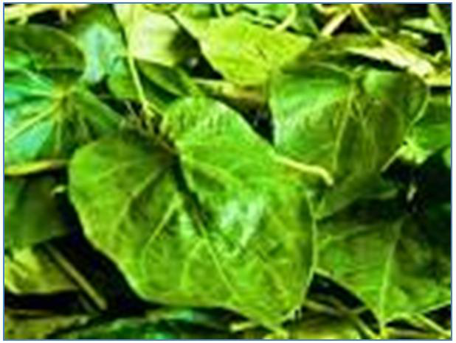

Figure 3 The Gongronema latifolium plant

Fekri et al. (2022) conducted a study on the efficacy of photocatalytic and sonocatalytic processes using copper oxide nanoparticles (CuO NPs) synthesized from Peganum harmala seed extract for removing reactive blue 5 dye and organic compounds from textile effluent. Structural confirmation of CuO NPs was done using SEM, TEM, XRD, EDX, and FTIR techniques. Batch experiments were performed to analyze factors affecting dye removal efficiency, including contact time, pH, NPs dosage, and initial dye concentration. The results showed that the photocatalytic process achieved a higher degradation percentage (98.42%) compared to the sonocatalytic process (76.16%). Dye removal efficiency was insignificant in dark conditions. Optimal conditions for maximum dye removal were found with 0.15 g of CuO NPs and dye concentrations of 40 mg/L (photocatalytic) and 60 mg/L (sonocatalytic). Kinetic data followed a pseudo-second-order model with a high correlation coefficient (>0.99) for both processes. Isotherm studies favored the Langmuir model to describe CuO NPs' adsorptive behavior in dark conditions. GC-MS analysis showed over 87% degradation efficiency in removing organic compounds via the photocatalytic process.

Singh et al. (2019) conducted a study on the preparation of copper oxide nanoparticles (CuO NPs) using Psidium guajava leaf extract as a reducing and capping agent. The CuO NPs, characterized as mono-dispersed and spherical with an average size of 2-6 nm and a BET surface area of 52.6 m2/g, demonstrated excellent degradation efficiency for industrial dyes Nile blue (NB) and reactive yellow 160 (RY160). The removal rates were 93% for NB and 81% for RY160 in 120 min, with apparent rate constants of 0.023 and 0.014 min-1, respectively. The CuO catalyst showed reusability for photocatalytic dye degradation over five cycles and had low detection limits (LOD) of 4 and 9 mg/L for NB and RY160, respectively. The study suggests that biogenic CuO NPs are a promising option for water purification from industrial dye contamination due to their high efficiency, reusability, and green synthesis approach.

## **NUTRITIONAL USES OF *GONGRONEMA LATIFOLIUM***

The leaves of G. latifolium are used as vegetables in preparation of soups to which they add a bitter-sweet flavor (Iwu, 1988; Morebise & Fafunso, 1998). The leaves are also sometimes used to spice locally brewed beer (Edim et al., 2012). The soft stem is used as chewing stick in Sierra Leone (Mosango, 2015).

## **ETHNOMEDICAL USES OF *GONGRONEMA LATIFOLIUM***

There have been reports of various uses of Gongronema latifolium in folklore medicine by different ethnic groups. (Morebise & Fafunso, 1998) reported that the leaves of this plant are used by the Ikales of Ondo State of Nigeria to treat malaria, nausea and anorexia. Edet et al also reported that the leaf extract of G. latifolium is commonly used by the Efik and Quas tribes of Cross River state of Nigeria to treat malaria, diabetes, hypertension and constipation (Edet et al., 2011).

Mosango reported that *G. latifolium* is used in some West African communities to treat cough, intestinal worms, dysentery, dyspepsia and malaria. He reported that in Sierra Leone, an infusion or decoction of the stems with lime juice is taken to treat colic and stomach aches, while in Senegal and Ghana, *G. latifolium* leaves are rubbed on joints of children to help them walk while the boiled fruits of this plant are eaten as a laxative (Mosango, 2015). Essien et al reported that G. latifolium is used to treat cough in Nigeria (Edet et al., 2011). Asthmatic patients can chew the fresh leaves of G. latifolium to relieve wheezing while a cold maceration of the roots of the plant can be consumed as treatment for asthma (Essien et al., 2007; Mosango, 2015). Mosango also reported the use of this plant in some communities to treat viral hepatitis, bilharzia and other microbial infections(Mosango, 2015).

Iwu and Oliver-Bever reported that the leaves of G. latifolium are used in some local communities as a vermifuge and stomachic (Iwu, 1988; Oliver-Bever, 1986). Owu et al reported that the leaves are also used to treat dyspepsia in some local communities (Owu et al., 2012). Essien et al. reported that the leaves of G. latifolium are used to treat fowl cough in Nigeria(Essien et al., 2007).

In recent years, in the field of nanotechnology, metal and metal oxide nanoparticles have been the most developed materials due to their modified and adjustable morphology, physicochemical properties, small size, and enormous surface area (Gusmão et al., 2013; Khan et al., 2020). They find various applications such as agricultural research, pharmaceuticals, biological, and environmental. Among the various metal and metal oxide nanoparticles, copper oxide (CuO) nanoparticles have a wide and direct band gap of 1.2–2.1 eV, are a member of group II-VI of p-type semiconductors and monoclinic structures. They have become a potential candidate for environmental applications (Koffyberg & Benko, 1982; Weldegebrieal, 2020). Additionally, they exhibit low toxicity, high chemical and thermal stability, compatibility, easy synthesis route, variable morphology at the nanoscale, a high specific surface area, improved oxygen adsorption capacity, and low cost (Arunkumar et al., 2019; B S, 2016; Vinothkumar et al., 2019). In recent years, many well-defined CuO nanostructures have been synthesized, such as nanospheres (Xu et al., 2005), nanoflowers (Yu & Zhang, 2009), micromachines (Yang et al., 2013), nano leaves (Liang & Zhu, 2004), nanorods (Yu & Zhang, 2009), nanotubes (Cao et al., 2003), nanosheets (Jang & Kim, 2009), and nanorings (Liu et al., 2007) to improve the surface reactivity and properties of nanoparticles. Hence, researchers are attempting to develop clean, non-toxic and cost-effective methods that totally reduce the use of hazardous chemicals (Muthuvel et al., 2020).

# **CHAPTER THREE**

### **MATERIAL AND METHODS**

## **3.1 MATERIAL AND REAGENT USED**

1. Extract from *Gongronema Latifolium*
2. Copper nitrate trihydrate (95% Cu(NO3)2.3H2O)
3. Sodium hydroxide (99% NaOH)
4. Ethanol (97%)
5. Distilled water

## **3.2 APPARATUS AND EQUIPMENT**

1. Magnetic stirrer
2. Magnetic bar
3. pH meter
4. Thermometer
5. Electric blender
6. Oven
7. Furnace
8. Glass rods
9. Crucibles
10. Plastic bottles
11. Beakers
12. Conical flasks
13. Volumetric flasks
14. Spatula
15. Dropper
16. Paper tape
17. Whatman no 42 filter papers
18. Hand gloves
19. Nose masks
20. Measuring Cylinder

## 3.4 PREPARATION OF THE LEAF EXTRACT

Fresh leaves of *Gongronema Latifolium* were collected from Nsukka community in Nigeria. 10g of the leaves were thoroughly washed with distilled water to remove any dust, after which it was cut into small pieces and added into 100ml of water in a beaker and heated at 800C on an electric heater for 2 hours. After being cooled at room temperature, it was filtered using whatmann filter paper to extract the filtrate. The extract was stored in a container in a refrigerator until use.

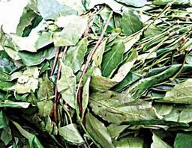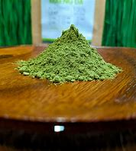

Figure 4: Gongronema latifolium leaves: (a) in the farm (b) washed and grinded

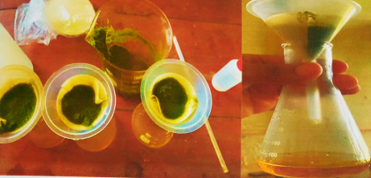

**Figure 5: Filteration process of the leaves extract**

## 3.5 GREEN SYNTHESIS OF COPPER OXIDE NANOPARTICLES

CuO nanoparticles were synthesized by using 0.1M Cu(NO3)2.3H2O. 100ml of the copper nitrates was taken in a 250ml Erlenmeyer Flask and 25ml of the *Gongronema Latifolium* extract was added slowly to reduce copper ions to its copper oxide nanoparticles. Then, 10ml of 2M NaOH solution was added to adjust pH to 11 while stirring it constantly. The solution was stirred continuously at 800C for 2 hours.

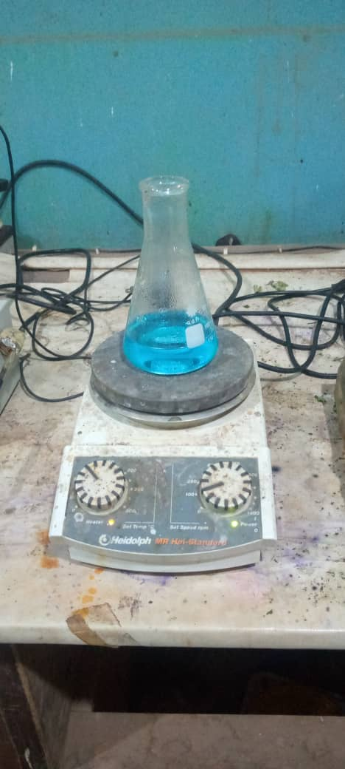 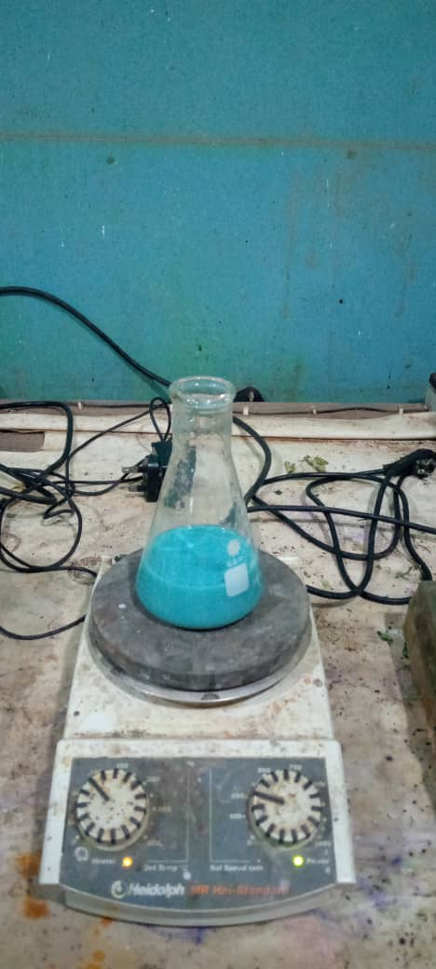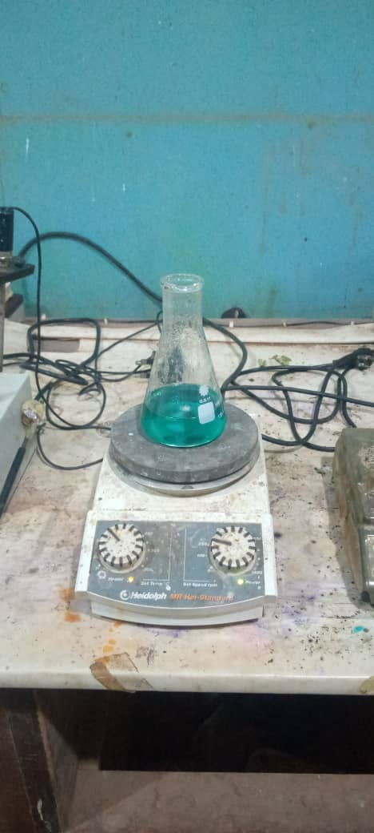

Figure 6: Copper solution colour change at different time

The blue coloured solution turned green immediately and after about 2 hours, a dark brown precipitate formed indicated that all the copper ions have been reduced and CuO nanoparticles have been formed. The obtained precipitate was centrifugated at 10,000 rpm for 10mins and washed several times using distilled water and ethanol for removal of impurities, and the sample was dried at 800c for 2hours.

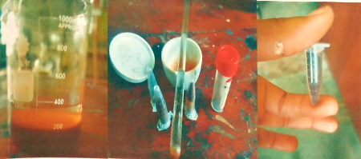

Figure 7: (a) separation after 24hrs (b) grinding process of the GSCu-NPs after drying and annealing (c) green synthesized GSCu-NPs

Preparation of 100ml of Cu(NO3)2.3H2O

Mass = 2.42g of Cu(NO3)2.3H2O

Preparation of 10ml of NaOH

$$Mass= \frac{molarity X molecular weight X volume}{1000{cm}^{3}}$$

$$Mass= \frac{2 X 40 X 10ml}{1000}$$

Mass = 0.8g NaOH

## 3.5 Characterization and Analysis

UV

Ultraviolet–visible spectroscopy or ultraviolet-visible spectrophotometry (UV-Vis or UV/Vis) refers to absorption spectroscopy or reflectance spectroscopy in the ultraviolet-visible spectral region. This means it uses light in the visible and adjacent (near-UV and near-infrared (NIR)) ranges. The absorption or reflectance in the visible range directly affects the perceived color of the chemicals involved. In this region of the electromagnetic spectrum, molecules undergo electronic transitions(Sahoo et al., 2012).

Reference

Adekanle, E., & Omozokpia, U. M. (2015). Antioxidant potentials of Gongronema latifolium (utazi) leaf extracts. *Environmental Science, Medicine*. https://doi.org/10.4314/BIOKEM.V27I2

Adil, S. F., Assal, M. E., Khan, M., Al-Warthan, A., Siddiqui, M. R. H., & Liz-Marzán, L. M. (2015). Biogenic synthesis of metallic nanoparticles and prospects toward green chemistry. *Dalton Transactions*, *44*(21), 9709–9717. https://doi.org/10.1039/C4DT03222E

Akintelu, S. A., Folorunso, A. S., Folorunso, F. A., & Oyebamiji, A. K. (2020). Green synthesis of copper oxide nanoparticles for biomedical application and environmental remediation. *Heliyon*, *6*(7), e04508. https://doi.org/10.1016/j.heliyon.2020.e04508

Arunkumar, B., Johnson Jeyakumar, S., & Jothibas, M. (2019). A sol-gel approach to the synthesis of CuO nanoparticles using Lantana camara leaf extract and their photo catalytic activity. *Optik*, *183*, 698–705. https://doi.org/10.1016/j.ijleo.2019.02.046

B S, B. M. (2016). Effect of precipitating agent NaOH on the preparation of copper oxide nanostructures for electrochemical applications. *НаносистеМы: Физика, ХиМия, МатеМатика*, *7*, 482–487.

Cao, M., Hu, C., Wang, Y., Guo, Y., Guo, C., & Wang, E. (2003). A controllable synthetic route to Cu, Cu2O, and CuO nanotubes and nanorodsElectronic supplementary information (ESI) available: EDS patterns of nanotubes and SEM images of nanorods. See http://www.rsc.org/suppdata/cc/b3/b304505f/. *Chemical Communications*, *15*, 1884. https://doi.org/10.1039/b304505f

Chattopadhyah, R. (1999). A comparative evaluation of some blood sugar lowering agents of plant origin. *J. Ethnopharmacol.*, 367–372.

Chauhan, M., Kaur, N., Bansal, P., Kumar, R., Srinivasan, S., & Chaudhary, G. R. (2020). Proficient Photocatalytic and Sonocatalytic Degradation of Organic Pollutants Using CuO Nanoparticles. *Journal of Nanomaterials*, *2020*, 1–15. https://doi.org/10.1155/2020/6123178

Chidi. (2017). ANTI-HYPERGLYCEMIC AND ANTI-OXIDANT ACTIVITIES OF METHANOL EXTRACT OF GONGRONEMA LATIFOLIUM. *Universal Journal of Pharmaceutical Research*, *2*(2), 35–38. https://doi.org/10.22270/ujpr.v2i2.R4

Dias, M. C., Pinto, D. C. G. A., & Silva, A. M. S. (2021). Plant Flavonoids: Chemical Characteristics and Biological Activity. *Molecules*, *26*(17), 5377. https://doi.org/10.3390/molecules26175377

Edet, E., Akpanabiatu, M., Uboh, F., Edet, T., Eno, A., & Itam, E. (2011). Gongronema latifolium crude leaf extract reverses alterations in haematological indices and weight-loss in diabetic rats. *J Pharmacol Toxicol*, *6*(2), 174–181.

Edim, E., Egomi, U., Ekpo, U., & Archibong, E. (2012). A review on Gongronema latifolium (Utasi): A novel antibiotic against Staphylococcus aureus related infections. *International Journal of Biochemistry and Biotechnology*, *1*(8), 204–208.

Essien, J., Ebong, G., & Akpan, E. (2007). Antioxidant and antitussive properties of Gongronema latifolium leaves used locally for the treatment of fowl cough in Nigeria. *J Appl Sci Environ Manage*, *11*(4), 47–50.

Fekri, R., Mirbagheri, S.-A., Fataei, E., Ebrahimzadeh-Rajaei, G., & Taghavi, L. (2022). Green synthesis of CuO nanoparticles using Peganum harmala extract for photocatalytic and sonocatalytic degradation of reactive dye and organic compounds. *Main Group Chemistry*, *21*(4), 975–996. https://doi.org/10.3233/MGC-220045

Gao, X., Wang, J., Yang, K., Zhao, B., & Deng, J. (2022). Regulating the Helical Chirality of Racemic Polyacetylene by Chiral Polylactide for Realizing Full-Color and White Circularly Polarized Luminescence. *Chemistry of Materials*, *34*(13), 6116–6128. https://doi.org/10.1021/acs.chemmater.2c01285

Gusmão, K. A. G., Gurgel, L. V. A., Melo, T. M. S., & Gil, L. F. (2013). Adsorption studies of methylene blue and gentian violet on sugarcane bagasse modified with EDTA dianhydride (EDTAD) in aqueous solutions: Kinetic and equilibrium aspects. *Journal of Environmental Management*, *118*, 135–143. https://doi.org/10.1016/j.jenvman.2013.01.017

Hutchinson, J., & Dalziel, J. (1931). *Flora of West Tropical Africa*. The Crown Agents for the Colonies.

Iwu, M. (1988). *Dietary plants and masticatories as sources of biologically active substances*. 70–379.

Jadoun, S., Arif, R., Jangid, N. K., & Meena, R. K. (2021). Green synthesis of nanoparticles using plant extracts: A review. *Environmental Chemistry Letters*, *19*(1), 355–374. https://doi.org/10.1007/s10311-020-01074-x

Jang, K.-S., & Kim, J.-D. (2009). Facile and Large-Scale Route to the Fabrication of CuO Nanosheets from a Lamellar Mesophase and Their Reversible Self-Assembly. *Langmuir*, *25*(11), 6028–6031. https://doi.org/10.1021/la9009652

Joshi, A., Sharma, A., Bachheti, R. K., Husen, A., & Mishra, V. K. (2019). Plant-Mediated Synthesis of Copper Oxide Nanoparticles and Their Biological Applications. In A. Husen & M. Iqbal (Eds.), *Nanomaterials and Plant Potential* (pp. 221–237). Springer International Publishing. https://doi.org/10.1007/978-3-030-05569-1_8

Khan, I., Khan, A. A., Khan, I., Usman, M., Sadiq, M., Ali, F., & Saeed, K. (2020). Investigation of the photocatalytic potential enhancement of silica monolith decorated tin oxide nanoparticles through experimental and theoretical studies. *New Journal of Chemistry*, *44*(31), 13330–13343. https://doi.org/10.1039/D0NJ00996B

Koffyberg, F. P., & Benko, F. A. (1982). A photoelectrochemical determination of the position of the conduction and valence band edges of *p* -type CuO. *Journal of Applied Physics*, *53*(2), 1173–1177. https://doi.org/10.1063/1.330567

Liang, Z.-H., & Zhu, Y.-J. (2004). Microwave-assisted Synthesis of Single-crystalline CuO Nanoleaves. *Chemistry Letters*, *33*(10), 1314–1315. https://doi.org/10.1246/cl.2004.1314

Liu, Y., Liao, L., Li, J., & Pan, C. (2007). From Copper Nanocrystalline to CuO Nanoneedle Array: Synthesis, Growth Mechanism, and Properties. *The Journal of Physical Chemistry C*, *111*(13), 5050–5056. https://doi.org/10.1021/jp069043d

Madani, M., Hosny, S., Alshangiti, D. M., Nady, N., Alkhursani, S. A., Alkhaldi, H., Al-Gahtany, S. A., Ghobashy, M. M., & Gaber, G. A. (2022). Green synthesis of nanoparticles for varied applications: Green renewable resources and energy-efficient synthetic routes. *Nanotechnology Reviews*, *11*(1), 731–759. https://doi.org/10.1515/ntrev-2022-0034

Majumdar, D., & Ghosh, S. (2021). Recent advancements of copper oxide based nanomaterials for supercapacitor applications. *Journal of Energy Storage*, *34*, 101995. https://doi.org/10.1016/j.est.2020.101995

Mamari, H. H. A. (2021). Phenolic Compounds: Classification, Chemistry, and Updated Techniques of Analysis and Synthesis. In *Phenolic Compounds—Chemistry, Synthesis, Diversity, Non-Conventional Industrial, Pharmaceutical and Therapeutic Applications*. IntechOpen. https://doi.org/10.5772/intechopen.98958

Morebise, O. (2015). A Review on Gongronema latifolium, an Extremely Useful Plant with Great Prospects. *European Journal of Medicinal Plants*, *10*(1), 1–9. https://doi.org/10.9734/EJMP/2015/19713

Morebise, O., & Fafunso, M. (1998). Antimicrobial and phytotoxic activities of saponin extracts from two Nigerian edible medicinal plants. *Biokemistri*, *8*(2), 69–77.

Morebise, O., Fafunso, M., Makinde, J., & Olajide, O. (2006). Evaluation of the bioactivity of Gongronema latifolium leaf extract in rodents. *Science Focus*, *11*(1), 27–30.

Mosango, D. (2015). Gongronema latifolium Benth. Record from PROTA4U. *Plant Resources of Tropical Africa (PROTA)*.

Murphy, C. J. (2008). Sustainability as an emerging design criterion in nanoparticle synthesis and applications. *Journal of Materials Chemistry*, *18*(19), 2173. https://doi.org/10.1039/b717456j

Muthuvel, A., Jothibas, M., Manoharan, C., & Jayakumar, S. J. (2020). Synthesis of CeO2-NPs by chemical and biological methods and their photocatalytic, antibacterial and in vitro antioxidant activity. *Research on Chemical Intermediates*, *46*(5), 2705–2729. https://doi.org/10.1007/s11164-020-04115-w

Nzilu, D. M., Madivoli, E. S., Makhanu, D. S., Wanakai, S. I., Kiprono, G. K., & Kareru, P. G. (2023). Green synthesis of copper oxide nanoparticles and its efficiency in degradation of rifampicin antibiotic. *Scientific Reports*, *13*(1), 14030. https://doi.org/10.1038/s41598-023-41119-z

Oliver-Bever, B. (1986). *Medicinal plants in tropical West Africa* (p. 90). Cambridge University Press.

Owu, D., Nwokocha, C., Obembe, A., Essien, A., Ikpi, D., & Osim, E. (2012). Effect of Gongronema latifolium ethanol leaf extract on gastric acid secretion and cytoprotection in Streptozotocin-induced diabetic rats. *West Indian Med J*, *61*(9).

Panhwar, S., Buledi, J. A., Mal, D., Solangi, A. R., Balouch, A., & Hyder, A. (2021). Importance and Analytical Perspective of Green Synthetic Strategies of Copper, Zinc, and Titanium Oxide Nanoparticles and their Applications in Pathogens and Environmental Remediation. *Current Analytical Chemistry*, *17*(8), 1169–1181. https://doi.org/10.2174/1573411017999201125124513

Rafique, M., Shafiq, F., Ali Gillani, S. S., Shakil, M., Tahir, M. B., & Sadaf, I. (2020). Eco-friendly green and biosynthesis of copper oxide nanoparticles using Citrofortunella microcarpa leaves extract for efficient photocatalytic degradation of Rhodamin B dye form textile wastewater. *Optik*, *208*, 164053. https://doi.org/10.1016/j.ijleo.2019.164053

Raizada, P., Sudhaik, A., Patial, S., Hasija, V., Parwaz Khan, A. A., Singh, P., Gautam, S., Kaur, M., & Nguyen, V.-H. (2020). Engineering nanostructures of CuO-based photocatalysts for water treatment: Current progress and future challenges. *Arabian Journal of Chemistry*, *13*(11), 8424–8457. https://doi.org/10.1016/j.arabjc.2020.06.031

Ranjha, M. M. A. N., Shafique, B., Rehman, A., Mehmood, A., Ali, A., Zahra, S. M., Roobab, U., Singh, A., Ibrahim, S. A., & Siddiqui, S. A. (2022). Biocompatible nanomaterials in food science, technology, and nutrient drug delivery: Recent developments and applications. *Frontiers in Nutrition*, *8*, 778155.

Saghir, S., Fu, E., & Xiao, Z. (2020). Synthesis of CoCu-LDH nanosheets derived from zeolitic imidazole framework-67 (ZIF-67) as an efficient adsorbent for azo dye from waste water. *Microporous and Mesoporous Materials*, *297*, 110010. https://doi.org/10.1016/j.micromeso.2020.110010

Sahoo, U., Seth, A., & Chawla, R. (2012). *UV/Visible Spectroscopy: Absorption Spectroscopy*. LAP LAMBERT Academic Publishing.

Sibhatu, A. K., Weldegebrieal, G. K., Sagadevan, S., Tran, N. N., & Hessel, V. (2022). Photocatalytic activity of CuO nanoparticles for organic and inorganic pollutants removal in wastewater remediation. *Chemosphere*, *300*, 134623.

Singh, J., Kumar, V., Kim, K.-H., & Rawat, M. (2019). Biogenic synthesis of copper oxide nanoparticles using plant extract and its prodigious potential for photocatalytic degradation of dyes. *Environmental Research*, *177*, 108569. https://doi.org/10.1016/j.envres.2019.108569

Udoidong, A., Etuk, B., & Udo, I. (2014). *Phytochemical and chromatographic analysis of chloroform extract of Marsdenia latifelia.*

US EPA, O. (2015, October 22). *Municipal Wastewater* [Collections and Lists]. https://www.epa.gov/npdes/municipal-wastewater

Vinothkumar, P., Manoharan, C., Shanmugapriya, B., & Bououdina, M. (2019). Effect of reaction time on structural, morphological, optical and photocatalytic properties of copper oxide (CuO) nanostructures. *Journal of Materials Science: Materials in Electronics*, *30*(6), 6249–6262. https://doi.org/10.1007/s10854-019-00928-7

Weldegebrieal, G. K. (2020). Photocatalytic and antibacterial activityof CuO nanoparticles biosynthesized using Verbascum thapsus leaves extract. *Optik*, *204*, 164230. https://doi.org/10.1016/j.ijleo.2020.164230

Xu, Y., Chen, D., & Jiao, X. (2005). Fabrication of CuO Pricky Microspheres with Tunable Size by a Simple Solution Route. *The Journal of Physical Chemistry B*, *109*(28), 13561–13566. https://doi.org/10.1021/jp051577b

Yang, C., Su, X., Wang, J., Cao, X., Wang, S., & Zhang, L. (2013). Facile microwave-assisted hydrothermal synthesis of varied-shaped CuO nanoparticles and their gas sensing properties. *Sensors and Actuators B: Chemical*, *185*, 159–165. https://doi.org/10.1016/j.snb.2013.04.100

Yang, C., Zhang, C., & Liu, L. (2018). Excellent degradation performance of 3D hierarchical nanoporous structures of copper towards organic pollutants. *Journal of Materials Chemistry A*, *6*(42), 20992–21002. https://doi.org/10.1039/C8TA07973K

Yu, Y., & Zhang, J. (2009). Solution-phase synthesis of rose-like CuO. *Materials Letters*, *63*(21), 1840–1843. https://doi.org/10.1016/j.matlet.2009.05.061

Zoolfakar, A. S., Rani, R. A., Morfa, A. J., O’Mullane, A. P., & Kalantar-zadeh, K. (2014). Nanostructured copper oxide semiconductors: A perspective on materials, synthesis methods and applications. *J. Mater. Chem. C*, *2*(27), 5247–5270. https://doi.org/10.1039/C4TC00345D